**Key: N/A Answers**

**Deletion Test**

**Instructions**: Identify the current node in each step and what rule you would apply if any. Show all of your work. (Nodes with a double circle are red, and x is the current node)

**Rules:**

* Do nothing (keep traversing down)
* Color flip
* Replace and delete
* Recolor root black
* Single rotation
* Double rotation
* Drop and rotate
* Swap values
* Simple delete

1. Delete 11: 2 pts.

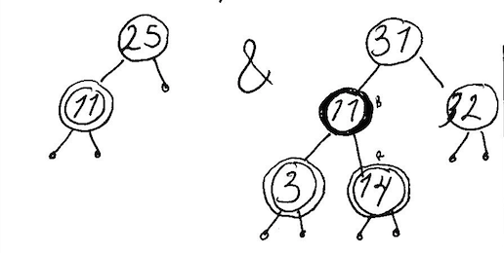

1. Delete 26: 3 pts.

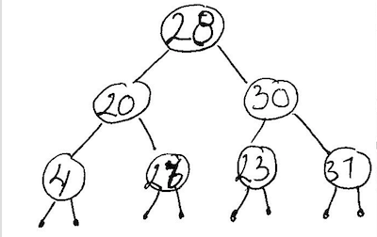

1. Delete 10: 2 pts.

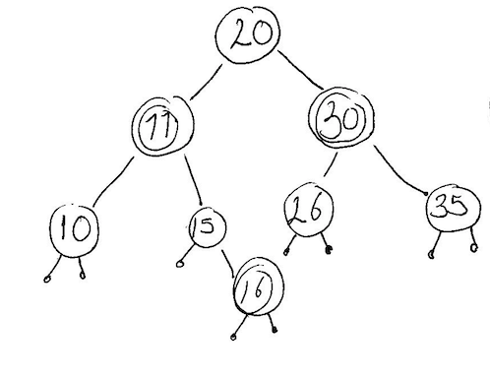

1. Delete 20: 2 pts.

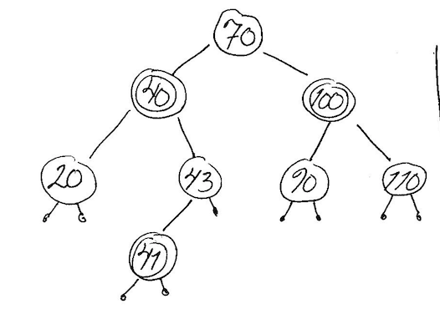

1. Delete 25: 4 pts.

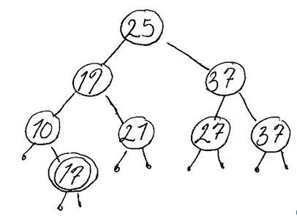

1. Delete 3: 2 pts.

